Definition

The **central tendency is stated as the statistical measure that represents the single value of the entire distribution or a dataset. It aims to provide an accurate description of the entire data in the distribution**

The central tendency measure is defined as the number used to represent the center or middle of a set of data values. The three commonly used measures of central tendency are the mean, median, and mode.

## Measures of Central Tendency

The central tendency of the dataset can be found out using the three important measures namely mean, median and mode.

## Mean

The mean represents the average value of the dataset. It can be calculated as the sum of all the values in the dataset divided by the number of values. In general, it is considered as the arithmetic mean.

### **Mean**

“Average” value is termed as the mean of the dataset. It is very easy to calculate the mean.

**Steps to calculate Mean:**

* **Step 1**. Count the number of data values. Let it be n.
* **Step 2**. Add all the data values. Let the sum be s.
* **Step 3**. Mean = Sum of all data values (s)/Total number of data values(n)

### **Median**

Median is the middle value of the dataset in which the dataset is arranged in the ascending order or in descending order. When the dataset contains an even number of values, then the median value of the dataset can be found by taking the mean of the middle two values.

### **Median**

The middle value of the sorted dataset is called the median.  Consider a dataset comprising ‘n’ elements.

**Steps to calculate median:**

* **Step 1**. The dataset is arranged in either increasing or decreasing order.
* **Step 2**. If the data set has an odd number of data values (n=odd), then the middlemost value of the sorted dataset is computed as the median. In other words, the data at (n + 1)/2 place is the median of the dataset.
* **Step 3**. If the dataset has an even number of data values (n = even), the average of two middle values is computed as the median. i.e. mean of (n/2) and {(n/2) + 1}th is the median of the dataset.

Consider the given dataset with the odd number of observations arranged in descending order – 23, 21, 18, 16, 15, 13, 12, 10, 9, 7, 6, 5, and 2

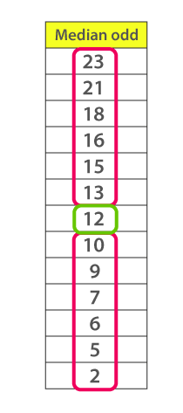

Here 12 is the middle or median number that has 6 values above it and 6 values below it.

Now, consider another example with an even number of observations that are arranged in descending order – 40, 38, 35, 33, 32, 30, 29, 27, 26, 24, 23, 22, 19, and 17

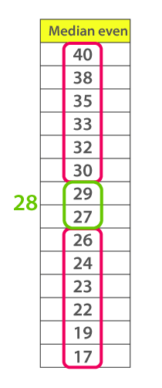

When you look at the given dataset, the two middle values obtained are 27 and 29.

Now, find out the mean value for these two numbers.

i.e.,(27+29)/2 =28

Therefore, the median for the given data distribution is 28.

### **Mode**

The mode represents the frequently occurring value in the dataset. Sometimes the dataset may contain multiple modes and, in some cases, it does not contain any mode at all.

### **Mode**

The most frequently occurring value in the dataset is called mode.

**Steps to calculate mode:**

* **Step 1**. Use tally marks to identify how many times each data value occurs in the dataset.
* **Step 2**. The data value with maximum tally is the mode of the dataset.

Consider the given dataset 5, 4, 2, 3, 2, 1, 5, 4, 5

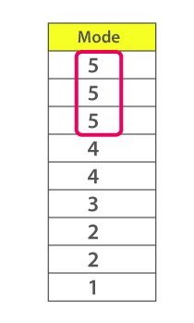

Since the mode represents the most common value. Hence, the most frequently repeated value in the given dataset is 5.